# Installation

## Install Anaconda (with Jupyter)

<https://docs.anaconda.com/anaconda/install/windows/>

1. [Download the Anaconda installer](https://www.anaconda.com/download/#windows).
   1. <https://www.anaconda.com/products/individual#windows>
2. Start the installation
3. Select a destination folder to install Anaconda and click the Next button. See [FAQ](https://docs.anaconda.com/anaconda/user-guide/faq/#distribution-faq-windows-folder).

**Note**:

* Install Anaconda to a directory path that does not contain spaces or unicode characters.
* Do not install as Administrator unless admin privileges are required.

1. Choose whether to add Anaconda to your PATH environment variable. We recommend not adding Anaconda to the PATH environment variable, since this can interfere with other software. Instead, use Anaconda software by opening Anaconda Navigator or the Anaconda Prompt from the Start Menu.
2. Choose whether to register Anaconda as your default Python. Unless you plan on installing and running multiple versions of Anaconda or multiple versions of Python, accept the default and leave this box checked.
3. Click the Install button. If you want to watch the packages Anaconda is installing, click Show Details.
4. Click the Next button.
5. Install Anaconda without PyCharm, click the Next button.
6. Done.

## Install Python and Visual Studio Code

**NOTE: Install Python 3.x (*DO NOT INSTALL Python 2.x*)**

* Install VS Code (<https://code.visualstudio.com/>)
* Install Python (<https://www.python.org/downloads>)

Along with the Python extension, you need to install a Python interpreter. Which interpreter you use is dependent on your specific needs, but some guidance is provided below.

**Windows**

Install [Python from python.org](https://www.python.org/downloads/). You can typically use the **Download Python** button that appears first on the page to download the latest version.

**macOS**

The system install of Python on macOS is not supported. Instead, an installation through [Homebrew](https://brew.sh/) is recommended. To install Python using Homebrew on macOS use brew install python3 at the Terminal prompt.

**Note:** On macOS, make sure the location of your VS Code installation is included in your PATH environment variable.

**Linux**

The built-in Python 3 installation on Linux works well, but to install other Python packages you must install pip with [get-pip.py](https://pip.pypa.io/en/stable/installing/#installing-with-get-pip-py).

* Install Python Extension for VS Code
  + Open VS Code and install the extension from:

<https://marketplace.visualstudio.com/items?itemName=ms-python.python>

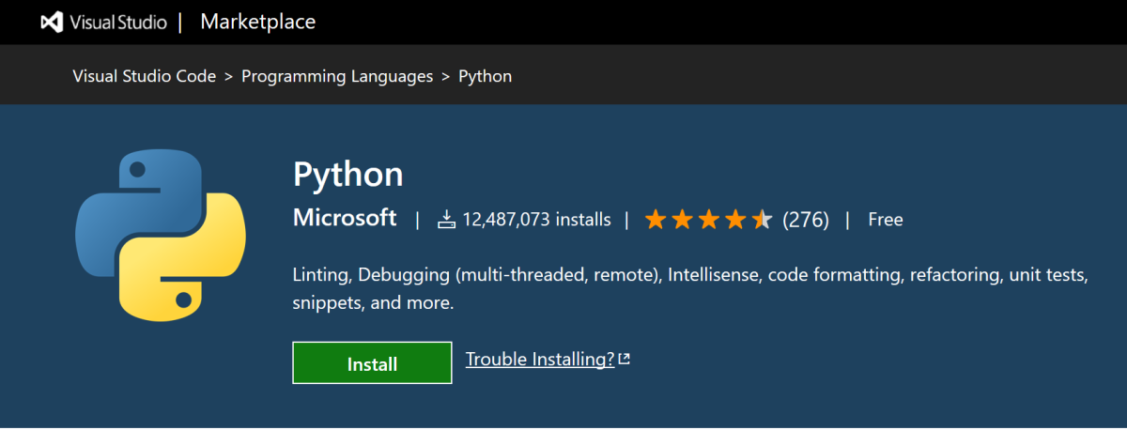

* + Once you have a version of Python installed, activate it using the **Python: Select Interpreter** command.
  + If VS Code doesn't automatically locate the interpreter you're looking for, refer to [Environments - Manually specify an interpreter](https://code.visualstudio.com/docs/python/environments#_manually-specify-an-interpreter).
  + You can configure the Python extension through settings. Learn more in the [Python Settings reference](https://code.visualstudio.com/docs/python/settings-reference).
* Verify Python installation
  + python –version
  + py –version
* From the terminal window, create a folder and navigate to that folder
* Open that folder in VS Code
* Create a file named hello.py and add the following code to it and save the file:

msg = "Hello World"

print(msg)

* The Python extension then provides shortcuts to run Python code in the currently selected interpreter (**Python: Select Interpreter** in the Command Palette):
  + In the text editor: right-click anywhere in the editor and select **Run Python File in Terminal**. If invoked on a selection, only that selection is run.
  + In Explorer: right-click a Python file and select **Run Python File in Terminal**.